Radiated Emission Test Report

Contents

1. Test lab facility 2

Test Site: 2

Facility name: 2

Facility address: 2

Facility site description: 2

Test Standards 2

EMC Directive 2014/30/EU 2

Test Equipment: 2

Environmental conditions: 2

Test Operator and Date: 2

2. Product Information 3

3. EUT setup 3

Photograph of EUT: 3

4. Test Result 3

5. Summary 3

# Test lab facility

## Test Site:

Facility name: Keysight Technology, Technology Order Fulfillment, Colorado Springs Hardware Test Center.

Facility address: 1900 Garden of the Gods Rd, Colorado Springs, CO. 80920

Facility site description:

3 Meter Semi-echoic chamber.

Note: *The radiated RF disturbance measurements were performed on an alternate test site of a semi–anechoic chamber at a 3 m distance. The 3 m test distance on an alternate test site is allowed because the EUT met the definition of small equipment in clause 3.10 and per clause 8.4 of CISPR 11:2009+A1:2010. The alternate test site semi–anechoic chamber meets the volumetric NSA validation requirements in CISPR 16–1–4 for the ±–4 dB from theoretical at all positions and antenna polarizations in the test volume*. *The limit for 10 meter site is adjusted by 10dB to fit 3 meter site.*

## Test Standards

### EMC Directive 2014/30/EU

IEC 61326-1:2012 / EN 61326-1:2013 (Basic) Radiated Emission Reference Standards:

CISPR 11:2009+A1:2010 / EN 55011:2009+A1:2010 Group 1 Class A. The products were tested in a typical configuration with Keysight Technologies test systems. This product is intended for use in a basic electromagnetic environment.

## Test Equipment:

|  |  |
| --- | --- |
| MXE Receiver Address | USB0::0x0957::0x0f0b::MY51210168::0::INSTR |
| Turn Table Address | gpib8 |
| Antenna Address | gpib9 |
| MXE Model S/N | MXE N9038A MY51210168 |
| MXE Calibration date | 12/8/2015 |
| Turntable SN | ETS LIndergen Model 2090 MY70235245 |
| Turtable calibraton date | 12/1/2015 |
| Antenna SN | ETS LIndergen Model 3142E |
| Antenna calibration date | 12/1/2015 |
| System loss calibration date | 4/1/2016 |
| NSA calibration date | 12/1/2015 |
| Test Standard | CISPER 11 Group 1 Class A RE |
| Test Site | Colorado Springs TOF Hardware Test Center 3 Meter anechoic chamber |
| Test Voltage | 110V |

## Environmental conditions:

Temperature: 72°F; Humidity :50 RH

Note: There will be no effect to the result due to changes in mains voltage or frequency.

## Test Operator and Date:

Operator: Clifford; Report generated at: May.05,2016 2:45:45 PM

# Product Information

|  |  |
| --- | --- |
| Prodcuct Name: | Digital Oscilliscope |
| Product Model: | MSO3014 |
| Product SN: | MY5051145 |
| Project Stage: | PP |
| Deliver date of the test samples: | 4/15/2016 |
| DUT power: | Main |
| Auxiliary equipment list: | N/A |
| Model numbers covered by the test: | DSO3014 A/B model |
| .-Hardware Difference | Bandwidth |
| .-Software/firmware difference: | None |
| .-Cosmetic difference: | Label |
| Test Configuration | this is a test |

# EUT setup

## Photograph of EUT:

# Test Result

|  |  |  |  |  |  |  |  |  |  |  |
| --- | --- | --- | --- | --- | --- | --- | --- | --- | --- | --- |
| Freq (Hz) | Amplitude (dBuV) | TurnTable (degree) | Tower (cm) | Polar | QuasiPeak (dBuV) | Peak (dBuV) | Avg (dBuV) | DeltQ (dB) | DeltP (dB) | DeltA (dB) |
| 209997425.0 | 56.1 | 0.0 | 151.0 | H | 40.9 | 41.1 | 40.5 | -9.1 | -8.9 | -9.5 |
| 475003355.0 | 67.6 | 10.0 | 191.0 | H | 53.3 | 53.5 | 53.0 | -3.7 | -3.5 | -4.0 |
| 780005929.0 | 57.3 | 1.0 | 160.0 | H | 43.2 | 43.7 | 42.5 | -13.8 | -13.3 | -14.5 |
| 975008973.0 | 57.5 | 0.0 | 200.0 | H | 40.5 | 41.6 | 39.4 | -16.5 | -15.4 | -17.6 |

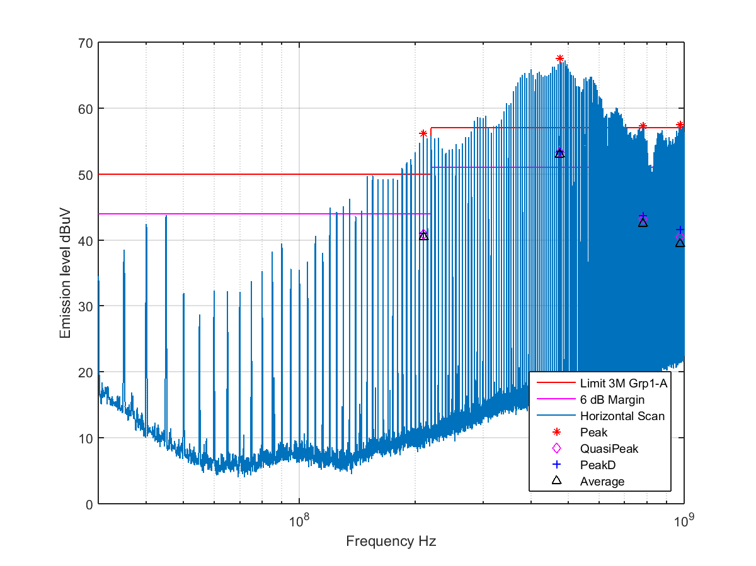

|  |  |  |  |  |  |  |  |  |  |  |
| --- | --- | --- | --- | --- | --- | --- | --- | --- | --- | --- |
| Freq (Hz) | Amplitude (dBuV) | TurnTable (degree) | Tower (cm) | Polar | QuasiPeak (dBuV) | Peak (dBuV) | Avg (dBuV) | DeltQ (dB) | DeltP (dB) | DeltA (dB) |
| 210002425.0 | 56.1 | 0.0 | 152.0 | V | 56.0 | 56.1 | 55.7 | 6.0 | 6.1 | 5.7 |
| 475003355.0 | 68.7 | 22.0 | 150.0 | V | 68.8 | 68.9 | 68.6 | 11.8 | 11.9 | 11.6 |
| 725003663.0 | 63.1 | 169.0 | 150.0 | V | 63.1 | 63.2 | 62.8 | 6.1 | 6.2 | 5.8 |
| 875004848.0 | 59.8 | 247.0 | 150.0 | V | 59.7 | 59.8 | 59.3 | 2.7 | 2.8 | 2.3 |
| 995009795.0 | 60.6 | 97.0 | 150.0 | V | 60.6 | 60.8 | 60.3 | 3.6 | 3.8 | 3.3 |

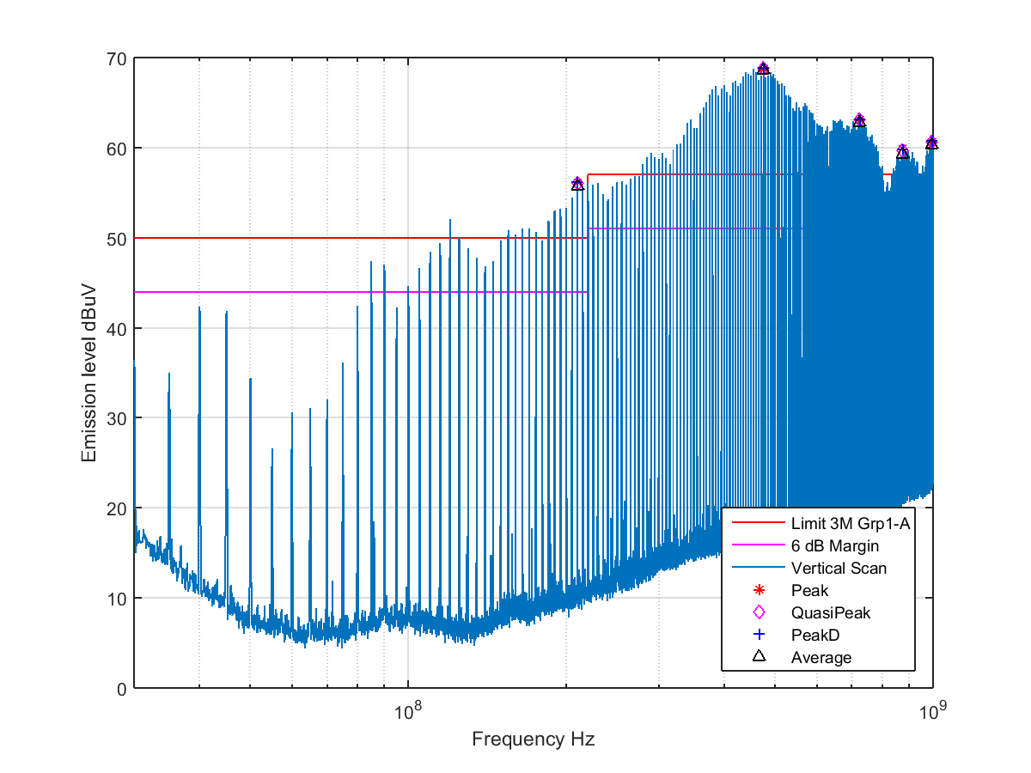

# Summary

The unit passed the Radiated Emission Test